**Air quality monitoring**

**Sensor**:

* Particulate Matter (PM) Sensors
* Gas Sensors
* Volatile Organic Compounds (VOC) Sensors
* Carbon Dioxide (CO2) Sensors
* Weather Sensors
* Hydrogen Sulfide (H2S) Sensors
* Ammonia (NH3) Sensors
* VOC Sensors
* Radon Gas Sensors
* Dust Sensors
* UV Sensors

**Dataset**:

* **Air Quality System (AQS) Data:** Comprehensive air quality data from the U.S. Environmental Protection Agency (EPA) covering the United States.
* **OpenAQ Data:** A global platform aggregating air quality data from various sources, including government monitoring stations and research institutions.
* **European Environment Agency (EEA) Air Quality Data:** Air quality data for European countries, providing information on pollutants like PM2.5 and PM10.
* **World Air Quality Index (WAQI):** Real-time and historical air quality data for numerous locations worldwide, including air quality indices.
* **The World Bank Air Quality Monitoring Data:** Air quality data for multiple countries and regions.
* **City-Specific Air Quality Portals:** Many cities maintain their own air quality data portals, accessible through local environmental agencies or city websites.
* **Kaggle Air Quality Datasets**: Kaggle hosts various air quality datasets, including historical data from monitoring stations worldwide
* **National Oceanic and Atmospheric Administration (NOAA):** NOAA provides weather and atmospheric data that can be integrated with air quality data for research.
* **University Research Datasets:** Explore datasets published by research institutions and universities, often related to air quality studies.
* **China Air Quality Data**: Datasets focused on air quality monitoring in different regions of China, where air pollution is a significant concern.
* **India Air Quality Data:** Datasets focused on air quality monitoring in various Indian cities, where air pollution is a significant issue.
* **Canadian Air Quality Data:** Air quality datasets from Canada, including information on pollutants and air quality indices.
* **Australia Air Quality Data**: Datasets related to air quality monitoring in various regions of Australia.

.**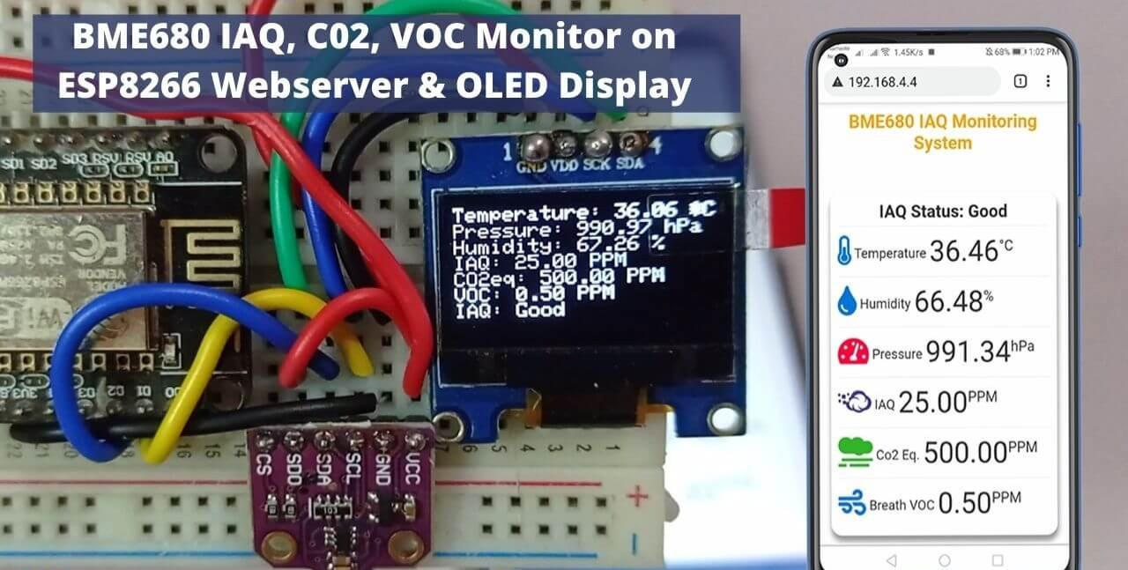Air quality monitoring: Python dumped in ic**

**Program**

**Const int sensorPin = A0; // Analog pin to read air quality sensor**

**Const int ledPin = 13; // LED connected to digital pin 13**

**Void setup() {**

**pinMode(ledPin, OUTPUT);**

**Serial.begin(9600);**

**}**

**Void loop() {**

**Int airQuality = analogRead(sensorPin);**

**Serial.println(“Air Quality: “ + String(airQuality));**

**If (airQuality > 500) {**

**digitalWrite(ledPin, HIGH);**

**} else {**

**digitalWrite(ledPin, LOW);**

**}**

**Delay(1000); // Delay for 1 second**

**}**

**Const int sensorPin = A0; // Analog pin to read MQ-135 sensor**

**Const int ledPin = 13; // LED connected to digital pin 13**

**Void setup() {**

**pinMode(ledPin, OUTPUT);**

**Serial.begin(9600);**

**}**

**Void loop() {**

**Int airQuality = analogRead(sensorPin);**

**Serial.print(“Analog Value: “);**

**Serial.println(airQuality);**

**If (airQuality > 400) {**

**digitalWrite(ledPin, HIGH);**

**Serial.println(“Air Quality: Poor (LED On)”);**

**} else {**

**digitalWrite(ledPin, LOW);**

**Serial.println(“Air Quality: Good (LED Off)”);**

**}**

**Delay(1000); // Delay for 1 second**

**}**

**Model results:**

* Air Quality Index (AQI): Categorizes air quality based on pollutant concentrations.
* Pollutant Concentrations: Predicts or estimates specific pollutant levels.
* Emission Source Identification: Identifies and quantifies pollution sources.
* Temporal Patterns: Reveals daily and seasonal air quality variations.
* Health Impact Assessment: Estimates health impacts of poor air quality.
* Weather-Related Influences: Shows how meteorological conditions affect air quality.
* Emission Reduction Scenarios: Simulates effects of emission reduction strategies.
* Air Quality Forecasting: Provides short-term and long-term air quality forecasts.
* Pollution Hotspots: Identifies areas with consistently poor air quality.
* Environmental Impact Assessment: Assesses air pollution’s impact on ecosystems.

**Benefits:**

* + Health Protection
  + Disease Prevention
  + Environmental Preservation
  + Regulatory Compliance
  + Policy Development
  + Emergency Response
  + Public Awareness
  + Healthcare Cost Reduction
  + Urban Planning
  + Agricultural Efficiency
  + Climate Change Mitigation
  + Research and Innovation
  + Quality of Life.

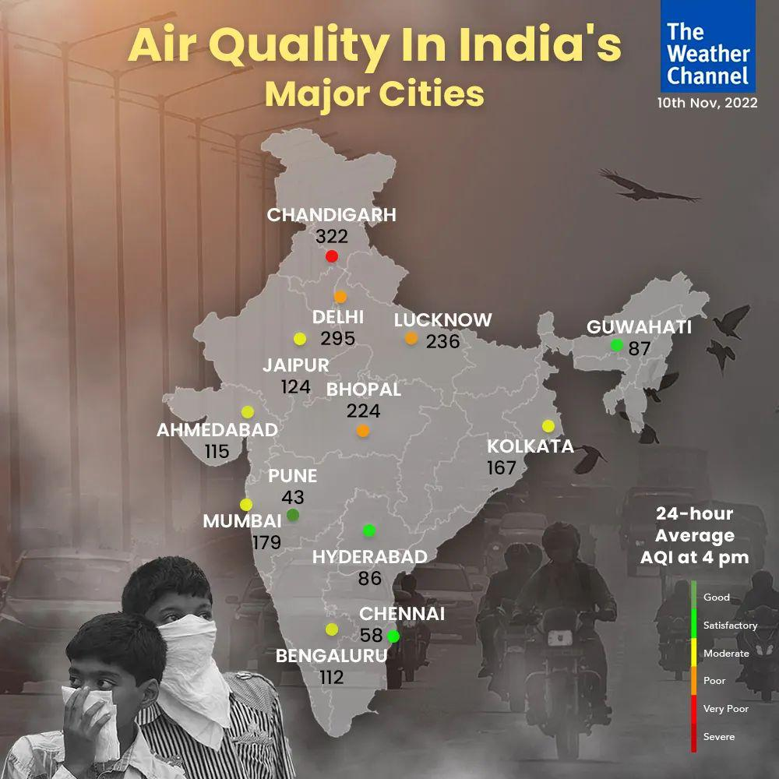

**Case studies:**

Delhi, India – Odd-Even Scheme: The Delhi government introduced the Odd-Even scheme, which restricts the use of private vehicles based on their registration numbers. Air quality monitoring data was used to justify the implementation of this policy during times of extreme air pollution, improving air quality during these periods.